**Q1. Using loop write a program to print numbers from 0 to 9.**

**Code:**

dosseg

.model small

.stack 100h

.data

.code

main proc

mov cx,10

mov dx,48

L1:

mov ah,2

int 21h

Add dx,1

Loop L1

mov ah,4ch

int 21h

main endp

end main

**Output:**

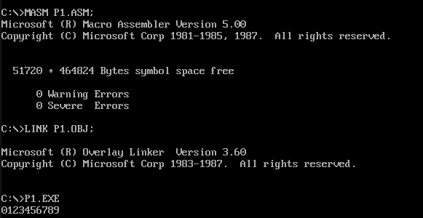

**Q2. Using loop write a program to print small letters a to z.**

**Code:**

dosseg

.model small

.stack 100h

.data

.code

main proc

mov cx,26

mov DX,97

L1:

mov ah,2

int 21h

inc dx

Loop L1

mov ah,4ch

int 21h

main endp

end main

**Output:**

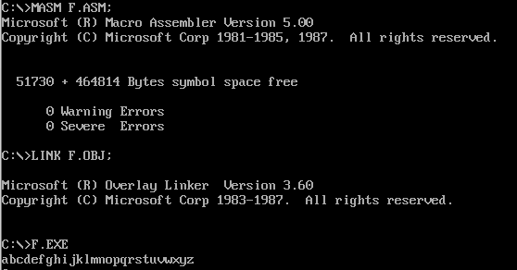

**Q3. Program to print the input number is equal or not to given number in program.(using jump)**

**Code:**

dosseg

.model small

.stack 100h

.data

msg1 db 'number is equal$'

msg2 db 'number is not equal$'

.code

main proc

mov ax,@data

mov ds,ax

mov dl,5

mov ah,7

int 21h

cmp al,dl

je L1

mov dx,offset msg2

mov ah,9

int 21h

mov ah,4ch

int 21h

L1:

mov dx,offset msg1

mov ah,9

int 21h

mov ah,4ch

int 21h

main endp

end main

**Output:**

